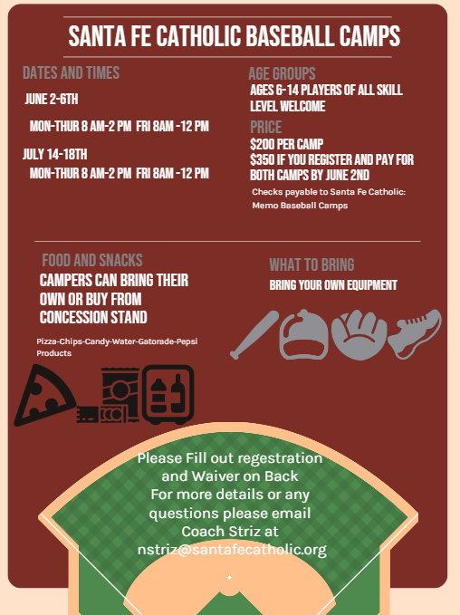

|  |  |  |  |  |  |  |  |
| --- | --- | --- | --- | --- | --- | --- | --- |
| Registration Form | | |  |  |  |  |  |
| Name:______________________________________________________ | | | | | | |  |
| Address:____________________________________________________ | | | | | | |  |
| City/Zip:____________________________________________________ | | | | | | |  |
| Parents Name____________________________________________________ | | | | | | |  |
| Contact number:_________________________________________________ | | | | | | |  |
| Email:_____________________________________________________ | | | | | | |  |
| T-Shirt Size:_____________________________________________________ | | | | | | |  |
| Age : |  |  |  |  |  |  |  |
| Release Form | |  |  |  |  |  |  |
| I understand that the applicant will be engaging in physical activity during the | | | | | | |  |
| program which contains an inherent risk on injury and the undersigned assumes | | | | | | | |
| the risk, and releases Santa Fe Catholic and the camp staff. | | | | |  |  |  |
| ___________________________________________________ | | | | | | Date________ | |
| Parent Signature | | |  |  |  |  |  |
| Mail To : Santa Fe Catholic High School C/O Nate Striz | | | | |  |  |  |
|  | 3110 Hwy 92 East | |  |  |  |  |  |
|  | Lakeland Florida 33801 | |  | Questions: contact Nate Striz at nstriz@santafecatholic.org | | | |

Coaches Working at the Camp:

Nate Striz: Santa Fe Catholic

Matt Saliba Webber University

Mitch Piatnik Webber University

Nolan Krause Davenport High School/LCB